Journal of Faculty of Engineering & Technology

**Journal homepage:** [**www.pu.edu.pk/journals/index.php/jfet/index**](http://www.pu.edu.pk/journals/index.php/jfet/index)

*12 Point spacing*

# COMBUSTION CHARACTERISTICS OF REACTIVE NANOMATERIALS (Centred)

*6 Point spacing*

First Author*1, Second Author2 and Third Author1<initial of others names><surname>(Centred)

*6 Point spacing*

*1Department of Some Engineering, University of the Punjab, Lahore, Pakistan +email

2Department of Some Discipline, University of Engineering and Technology Lahore, Pakistan+email(Centred)

*18 Point spacing*

**Abstract**

*6 Point spacing*

The combustion ofmetallic particlesis analogous to the combustion of hydrocarbon particles andthe particle burn time can be related to its diametric length. The relationship is called‘d’ law and represented as*tb=d2*. From the physics aspect, many deviations from the established laws at the bulk scale have been reported. As the ignition temperature of energetic nanomaterials is more sensitive to the passivation layer and the external heating conditions, and the burning time of nanomaterials is deviated from the conventional *d2* law. Due to the variation of certain parameters such as the particles size distribution, agglomeration, morphology, level of contamination and initial particle size,the correct and precise value of the exponentisdifficult to find. Consequently, there’s no universal law for the burn time and a variant of the *dn* law is always proposed whose exponent is less than 2 (~ 1.3-1.7).In this research, combustion experiments are performed using a Bunsen burner in a particle-laden methane stream and the relationship of particle burning time with particle diameter is found to be *tb ~ d1.2*. The combustion process of the various particles is captured using a high speed video camera. The average values of extinction time for Si (720 nm) and Si (1000 nm) are 11.4 ms and 17.2 ms, respectively. It is also observed that the nanoparticles are more reactive than the microsized particles. The average velocity flow fields of the silicon, iron and aluminum particles are also investigated using PIV technique.Before and after the experiments, the particles are characterised using dynamic light scattering (DLS), scanning electron microscopy (SEM), Energy-dispersive X-ray spectroscopy (EDS) and transmission electron microscopy (TEM).

*6 Point spacing*

**Keywords:** Reactive Nanomaterials, Particle Combustion, D Law, PIV, Particle Characterisation

1. *point spacing*

# 1.*0.2 HI* Introduction

*6 Point spacing*

The combustion of energetic metallic particles or particle suspensions have long been the area of interest in the combustion research community. Enormous research has been conducted to understand the mechanism of combustion of metallic particles either to improve the burning rate [1-3] or inhibit it for hazard prevention [4, 5]. The physics of oxidation of fine particles (nanoparticles or sometimes micro-sized particles exhibiting size-dependent behaviours) have been found to be different to that of conventional-sized particles (i.e. > 50 micrometres) [6]. As the physical and thermodynamical properties of the fine powders are different,the models describing the oxidation of conventional-sized powders make certain assumptions such that at any given instant the growth of oxide depends upon the diffusion of a single species etc.[7] . Such assumptions are not valid for the fine particles. For conventional-sized particles, the diffusion based oxidation is a good assumption, but for fine particles, the reaction is more likely to be kinetically controlled [6, 8].

*6 Point spacing*

The metals are normally ignited after achieving their boiling point. The volatility of the metal oxide relative to the metal and overall energy available for the gasification of both the metal and its oxide are very important factors in the phenomenological understanding of metal combustion. There are two possibilities for the combustion [9, 10] that 1) the metal relative to its oxide is volatile and the energy released during the reaction is sufficient to vaporize the oxide. This ensures that the combustion is homogenous and proceeds in the vapour phase via the diffusion of ions, 2) the metal relative to its oxide is non-volatile and oxidation energy is not enough to vaporize it. The combustion will be heterogeneous and proceed purely in the condensed phase[11]. Von Grosse and Conway [12] found that the flame temperature of the metal is limited to the volatilization-dissociation or boiling point of the oxide. If the oxide’s volatilization temperature is higher than the boiling point of the metal, the combustion will proceed heterogeneously, i.e., in the condensed phase, on the surface of metal particles. On the other hand, when the heat of reaction is sufficient to transform both the oxide and the metal into gas, the combustion will proceed in the vapour phase. This is called Glassman’s criteria for vapour phase combustion [58].

*6 Point spacing*

Glassman et al. [13]proposed that the combustion of conventional-sized aluminium particles is analogous to the combustion of hydrocarbon particles, and the burn time is related to the square of its diametric length, known as d2 law. Many differences have been reported on the combustion behaviour of fine particles and that of the conventional particles. The burning time of fine particles is a function of the particle morphology and the temperature and pressure of the environment[14]. Olsen and Beckstead [15, 16] observed that the burning time (tb) of microsized particles (40-70 m) was weakly related to the temperature of the surrounding gas. In the case of nanosized particles, Bazyn et al. [17]showed a strong dependence on the pressure of the surrounding gas, which concluded that the combustion process was kinetically controlled. Many studies [18-20] show that when the diameter of the particle becomes very small, the exponent of the conventional law of burn time, i.e., *tb = dn* becomes less than 2. However, due to the agglomeration and non-uniform dimensions of these nanoparticles, aprecise exponent number is not easy to find.

*6 Point spacing*

Various techniques including lasers, shocks, flashes and gas burners [21-23] have been developed to initiate the ignition. The combustion history of the particles is often tracked by the high speed cameras and the morphology is examined with the help of Electron Microscopes (EMs). The Particle Imaging Velocimetry (PIV) is used to measure the flame flow and analyse its characteristics[24].In this article combustion experiments are performed using a Bunsen burner in a particle-laden methane stream and the relationship of particle burning time with particle diameter is reported. The particles are characterised using DLS, SEM, EDS and TEM. A high speed video camera is used to capture the combustion process of the particles, and PIV technique is used to investigate the average velocity flow fields of the silicon, iron and aluminum particles. From the particle extinction time, the exponent of relationship the of tb= dn is obtained.

*12 Point spacing*

# 2. *0.2 HI* Materials and Methods

*6 Point spacing*

## *2.1.Materials*

Al, Si and Fe wereused in the combustion experimentation. The physical characteristics of nAl have already been reportedin ref. [25]. SEM and TEM images of nAl are shown in Figure 1

*12 Point spacing*

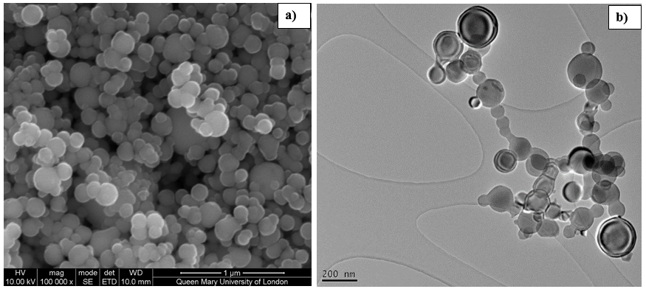

*6 Point spacing*

**Figure 1. SEM (a) and TEM (b) images of n-Aluminum particles show that the particles are spherical and agglomerated (before combustion).**

*12 Point spacing*

Two types of Si particles were purchased from Nanostructure and Amorphous Materials Ltd (USA), with a nominal particle size of 50 nm and 1000 nm respectively. However the 50-nm nanoparticles come with heavy agglomerations. To reflect the particle morphology upon combustion, some Si samples were dispersed into ethanol without any mechanical or chemical aid, and its size distribution is measured by DLS, as shown in **Figure 2**. The particles size distribution isin the range of 600 to 1000 nanometer, peaking at ~ 720 nm, which is much larger than the primary particle size of ~50nm. Iron powder having a grade Fe300 was purchased from William Rowland ltd. The Fe powder has diameter ranges from 45-75 m and an average density of 2.8-3.0 g/cm3. It was 99% pure and contained some trace elements likes C (0.01%), S (0.025%) and O2 (0.15%). All the particles were mixed with natural gas (CH4, 98%) and were combusted using a burner in the atmosphere of air. The particles were characterised with SEM, TEM and EDS employing the methods discussed in detail in the previous work [25].

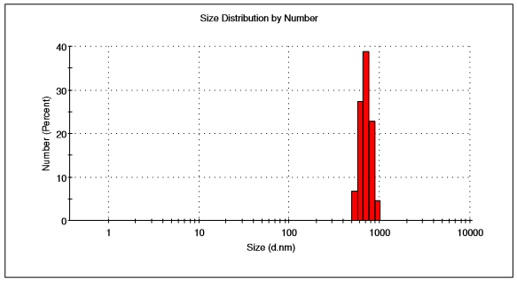

*6 Point spacing*

**Figure 2. Particle size ditribution (PSD) of Si (before combustion)**

1. *Point spacing*

## *2.2.Aerosol generation assembly*

The experimental set up consists of a methane del0on assembly. The particles were mixed with the methane stream through a belt conveying system, where the particles were loaded from a hopper onto a belt, which was driven by an electric motor (12 V). The amount of particles added into the gas stream was adjusted by the speed of the motor. For the experimental results reported below, the amount of methane was regulated at 2 l/min to ensure the uniform flow rate of the gas.

1. *Point spacing*

## *2.3.Image capture*

The combustion of the particles was recorded and subsequently interpreted with the help of a high speed video camera(Phantom V2.3) recording at a frequency of 1000 Hz with 256 by 128 pixel array. The recording was started once the flame became stable. The distance to pixel ratio (spatial resolution) was calculated as 14.5, 14.9 and 16.7 for Si (720 nm), Si (1 m) and Fe (45-75 m), respectively. The capture time in all experiments was maintained constant at 1 ms. The captured images were binarised using J-image software.

*12 Point spacing*

# 3. *0.2 HI* Results and Discussion

1. *Point spacing*

## *3.1.Particle characterisation*

SEM images of the particles after their combustion are shown in Figure 4and the EDS analyses are summarised in Table 1.

*6 Point spacing*

From the SEM images, it is observed that nanoparticles of Al and Si are still kept spherical. On the other hand, micrometric particles of Fe and Si are changed to big agglomerates of non-uniform shapes. Interestingly the EDS results of both nanometeric particles (Al and Si) show that it contains 55.46% (for Al) and 29.12% (for Si) of carbon. Contrary to that, the EDS of the micrometric particles does not show any signal of

carbon. This means that during the experiment fewer Fe particles were burnt.

*12 Point spacing*

**Table 1. EDS analyses of various powders after combustion.**

|  |  |  |  |  |  |
| --- | --- | --- | --- | --- | --- |
| **Samples** | **Products (%)** | | | | |
|  | O | C | Fe | Al | Si |
| nAl | 15.3 | 55.46 | No signal | 29.1 | 0.26 |
| Fe | 30.0 | No signal | 68.8 | No signal | 0.60 |
| Si (720 nm) | 59.17 | 29.12 | No signal | No signal | 11.7 |
| Si (1 m) | 54.67 | No signal | No signal | No signal | 45.3 |

1. *Point spacing*

## *3.2.Combustion experiments*

The particles are ignited/ combusted at atmospheric conditions in the stream of natural gas/air using a conventional Bunsen burner, which is a simple system that allows greater control over the combustion parameters.

*6 Point spacing*

The particles are ignited after passing through the inner core having the highest flame temperature. Typical particle combustion image showing distinct zones of the flame is presented in Figure 5.

*12 Point spacing*

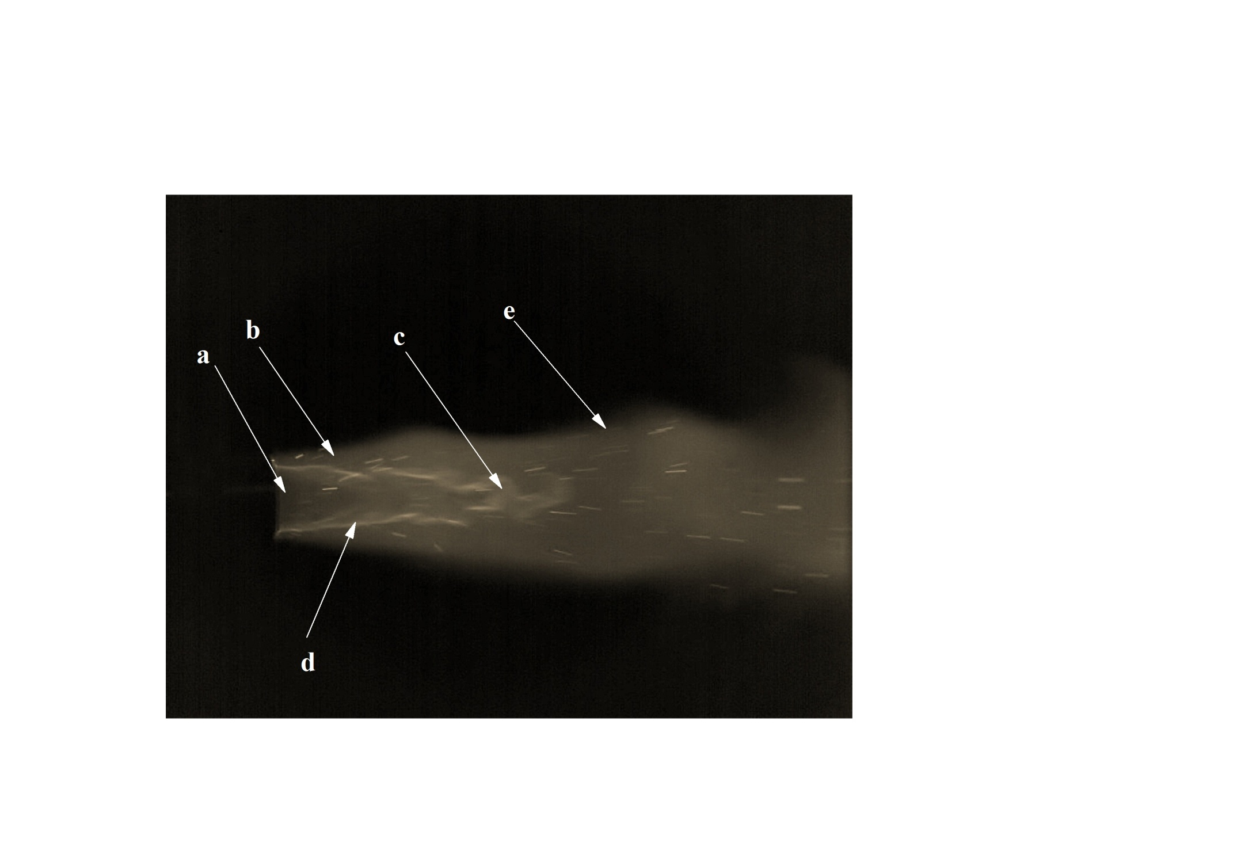

*6 Point spacing*

**Figure 5. Particle combustion in the stream of methane/air showing various regions of flame a) Cold flame zone; (b) Region of combustion; (c) Tip of inner one, hottest flame zone; (d) Region of intense combustion, inner cone; (e) Outer cone-post flame region.**

1. *Point spacing*

## *3.3.Comparison of reactivities of Si particles*

With the decrease of particle diameter, the specific surface area of the particle increases. This increases the contact points among the reactants and the particles. Consequently, the reactivity of the nano particles is higher than that of the micro particles. To reflect the particle morphology upon combustion, the peak particle size, i.e., 720 nm, rather than the primary particle size as supplied by the manufacturer. In the experiment particles of Si having 720 nm and 1 m diameter are combusted at the same experimental conditions, and their combustion behaviour is compared in Figure 6.

The pin stubs for collection of the combusted particles were mounted over the flame. It can be easily discerned from Figure 6 that the particles having a smaller diameter are characterised with higher reactivity as more particles are combusted during the combustion process. On the other hand, smallnumber of particles (Si 1 m) is combusted due to which the signal of carbon in the EDS results is missing.

*6 Point spacing*

## *3.4.PIV and extinction time results*

It is very important to have detailed knowledge of particle combustion behaviour particularly its combustion velocity in relation to its ignition and burning time. PIV experiments are used to find out the velocity profiles of the burning particles. A series of PIV experiments were performed to calculate and compare the flow fields and speeds of the various particles, shown in Figure 7 and Figure 8.

*12 Point spacing*

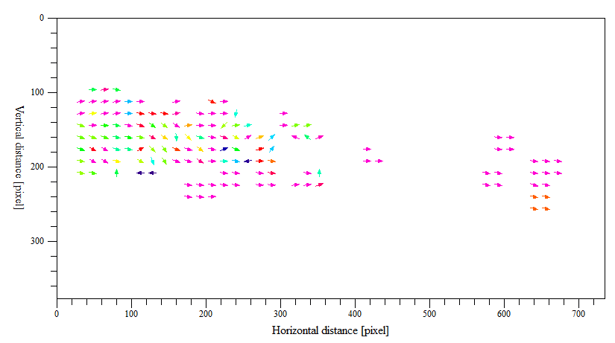

**a)**

*6 Point spacing*

**Figure 7. Showing the results of PIV of an image pair of Si (720 nm) particles, a) velocity vector field; b) average axial components of velocity.**

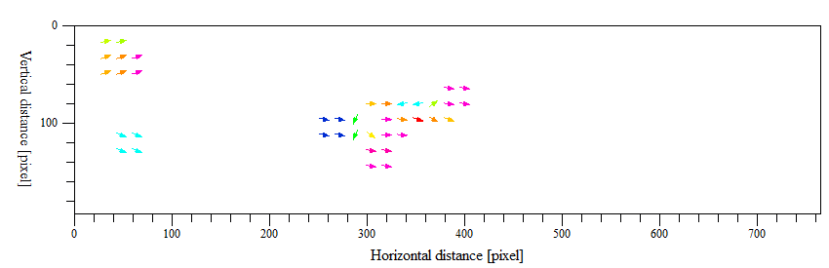

**a)**

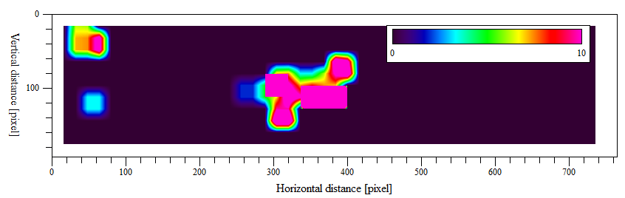

**b)**

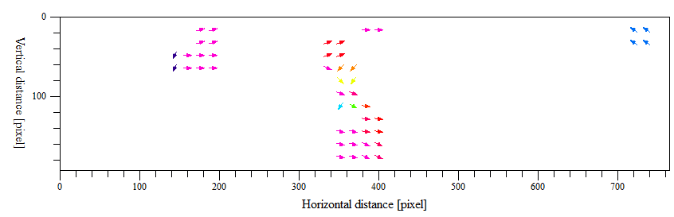

**d)**

**c)**

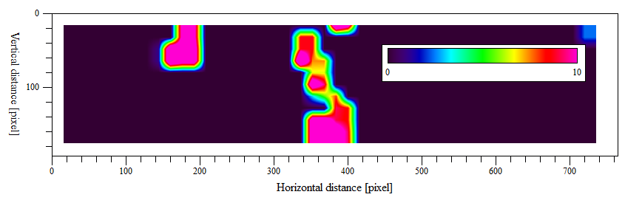

*6 Point spacing*

**Figure 8. Showing the PIV results of image pairs of Si (1000 nm) and Fe (45-75 m) particles, a) velocity vector field of Si; b) average components of velocity of Si; c)velocity vector field of Fe; d) average components of velocity of Fe.**



*6 Point spacing*

**Figure 9. Comparison of mean speeds of various particles by processing 50 image pairs.**

*12 Point spacing*

From Figure 7 and Figure 8, it can be observed that the ignitability/reactivity of the particles increase with the decrease of the diameter. The results of PIV profiles of Fe and Si having micrometric dimensions are similar to each other. It can be seen that the particles were ignited after passing through the tip of the internal cone which is the point of maximum temperature in the flame. In the post flame zone (outer cone) the particles extinctafter travelling some distance. The mean speed profile of 50 image pairs are represented and compared in Figure 9. The average speeds of Si (720 nm), Si (1 m) and Fe (45-75 m) in the methane stream are 1.18 m/s, 1.15 m/s and 1.71 m/s, respectively.

*6 Point spacing*

The diffusion limited droplet combustion theory predicts that the combustion time is related to the square of particle diameter, i.e., d2 law. However, with the decrease of particles size, the diffusion limited oxidation assumption becomes invalid and the oxidation transitions towards kinetically controlled. Various dn relationships are presented in the literature, depending upon the particles size, level of agglomeration, combustion and experimental conditions. These experiments demonstrate the large difference between conventional-sized particles and fine particles.

*12 Point spacing*

# 4. *0.2 HI* Conclusions

This research provides an investigation of the combustion characteristics of three particles, Al, Fe and Si, having variable dimensions in the methane/ air stream in a Bunsen burner setup. The following conclusions are made:

* Most of the particles are burned after passing through the inner flame cone.
* The chemical compositional analyses (EDS) show no carbon signals for the micrometric particle, which suggests small number of particles are burned during the experiment.
* The comparison of silicon particle with different sizes shows that the reactivity of the particle increase with the decrease of the diameter.
* The results clearly demonstrate that the conventional d2 law is not applicable to the fine particles.

*12 Point spacing*

**Acknowledgement**

*6 Point spacing*

Authors are highly thankful to the …………………………

*12 Point spacing*

# References

*6 Point spacing*

[1]**0.3HI** S. Goroshin, I. Fomenko, J.H.S. Lee, Burning velocities in fuel-rich aluminum dust clouds, Twenty-Sixth Symposium (International) on Combustion, Vols 1 and 2, (1996) 1961-1967.

[2] V.I. Levitas, Burn time of aluminum nanoparticles: Strong effect of the heating rate and melt-dispersion mechanism, Combustion and Flame, 156 (2009) 543-546.

[3] A. Hahma, A. Gany, K. Palovuori, Combustion of activated aluminum, Combustion and Flame, 145 (2006) 464-480.

[4] D.E.G. Jones, R. Turcotte, R.C. Fouchard, Q.S.M. Kwok, A.-M. Turcotte, Z. Abdel-Qader, Hazard Characterization of Aluminum Nanopowder Compositions, Propellants, Explosives, Pyrotechnics, 28 (2003) 120-131.

[5] Q.S.M. Kwok, C. Badeen, K. Armstrong, R. Turcotte, D.E.G. Jones, V.Y. Gertsman, Hazard characterization of uncoated and coated aluminium nanopowder compositions, J Propul Power, 23 (2007) 659-668.

[6] A. Rai, K. Park, L. Zhou, M.R. Zachariah, Understanding the mechanism of aluminium nanoparticle oxidation, Combustion Theory and Modelling, 10 (2006) 843-859.

[7] M.A. Trunov, M. Schoenitz, X.Y. Zhu, E.L. Dreizin, Effect of polymorphic phase transformations in Al2O3 film on oxidation kinetics of aluminum powders, Combustion and Flame, 140 (2005) 310-318.

[8] T.J. Campbell, G. Aral, S. Ogata, R.K. Kalia, A. Nakano, P. Vashishta, Oxidation of aluminum nanoclusters, Physical Review B, 71 (2005) 205413.

[9] I. Glassman, Combustion, Academic Press, Orlando, 1996.

[10] I. Glassman, Combustion of metals: physical considerations, Academic Press, New York, 1960.

[11] J.B.C. A.V. Von Grosse, Ind. Eng. Chem, 50 (1958) 663–672.

[12] A.V. Grosse, J.B. Conway, Combustion of Metals in Oxygen, Industrial & Engineering Chemistry, 50 (1958) 663-672.

[13] T.A. Brzustowski, I. Glassman, H.G. Wolfhard, L. Green, Heterogeneous Combustion, 1964.

[14] Y. Huang, G.A. Risha, V. Yang, R.A. Yetter, Combustion of bimodal nano/micron-sized aluminum particle dust in air, Proceedings of the Combustion Institute, 31 (2007) 2001-2009.

[15] M.W. Beckstead, A Summary of Aluminum Combustion, Conference paper, ( JAN 200) 47.

[16] S. Olsen, M. Beckstead, Burn time measurements of single aluminum particles in steam and carbon dioxide mixtures, 31st Joint Propulsion Conference and Exhibit, American Institute of Aeronautics and Astronautics1995.

[17] P.L. Tim Bazyn, Herman Krier, Nick Glumac, Combustion Measurements of Fuel-Rich Aluminum and Molybdenum Oxide Nano-Composite Mixtures, Propellants Explos. Pyrotech, (April 08, 2009) 1 – 10.

[18] E.L. Dreizin, On the mechanism of asymmetric aluminum particle combustion, Combustion and Flame, 117 (1999) 841-850.

[19] Y. Shoshin, E. Dreizin, Particle combustion rates in premixed flames of polydisperse metal—air aerosols, Combustion and Flame, 133 (2003) 275-287.